

FutureHealth Online

Helping address mental health issues on campuses
May | 2020


FutureHealth Online Proposal  2020-2021 | Presented by Michael T. Hmurcik FutureHealth  Direct: 413-858-2611  Email: mhmurcik@fhsmail.com

TABLE OF CONTENTS

PAGE
Overview………………………………………………………….………………………………………………………….…… 1

FutureHealth Program Benefits and Education………….……….………………………………………….. 2
- Benefits
- Who is it for?
- Prevention Education

Access and Outreach to Students………………………………………………………………………………….… 3
- Access
- FutureHealth’s Outreach Program
- Who is Q?
- Daily Inspirational Text Messages

Health Education Documentaries……………………………………………………………………………….…. 4

Health Promotion……………………………………………………………………………….……………….…………. 5

A Student Assistance Program (ASAP)…………………………………………………………………………… 6

FutureHealth has More to Offer……………………………………………………………………………………… 7

Our Goal and Getting Started……………………………………………………………………………………….… 8

Overview

FutureHealth is an online health and wellness education program that brings important information straight to its members. Our comprehensive education program includes topics such as alcohol use disorder, opioid use disorder, sexual misconduct, sleep deprivation, anxiety and stress, depression, eating disorders, diabetes, and personal safety.
Many schools already offer medical assistance and most of them provide mental health support for their members, but rarely do they offer education and prevention. Education is key to preventing the risky behaviors that can lead to issues further down the road.
The most common ways that Covid-19 has impacted student’s lives    In a mental health survey, students reported high levels of stress and anxiety, disappointment and sadness, and loneliness and isolation while campuses are closed.  – UniversityBusiness.com | How FutureHealth can help!  - Two (2) programs to choose from: FutureHealth Online and our A Student Assistance Program (ASAP)  - We provide your students with a foundation as to how critical issues (such as alcohol, opioids, anxiety, depression and more) can affect their daily life.  - By requiring your students to complete our testing modules on mental health & wellness issues, you are safeguarding against your students developing risky behaviors.  - FutureHealth Outreach Program checks in on your students daily through our Q initiative, a friendly buddy that reaches out to students.  - With our health promotion assistance, we work with you to create and disperse effective health promotion materials.
Pricing  Pricing is determined based on covered population:  FutureHealth Online Annual Rate: $2.00 per student/per year  Minimum annual rate of $5,000 dollars  (school determines eligibility)  A Student Assistance Program (ASAP): Contact FutureHealth for pricing |   A recent survey of 172 campus leaders put the mental health of their students and employees atop their list of short-term concerns.  -InsideHigherEd.com

Futurehealth Online program benefits and education

HIGHLIGHTS
- Testing modules on critical health issues (alcohol, opioids, depression and more)  - Quantifiable learning progression  - Administrators have access to aggregate data  - Ability to make data anonymous or with student’s name | - Self-risk assessments  - Reading material  - Additional resources  - Daily emails  - Healthy recipes  - Exercise tips  - Weekly blogs  - Certificates of Completion
BENEFITS
- Teaches individuals the dangers of certain behaviors  - Shows real-life outcomes of risky behaviors  - Helps members find facilities | - Gives members the tools to help others  - Promotes positive lifestyle  - Helps students learn anxiety-reducing practices

Who is it for?
FutureHealth can be purchased for your entire student population or for a select group. Our program is designed to give you flexibility in your approach to mental and physical health and wellness. The FutureHealth program provides your students with a singular resource to access information and helpful tools for critical issues they are likely to face. This will help them build a foundation for a successful college career by reducing risky behaviors.
- Incoming Freshman  - Undergraduate/Graduate students  - International Students | - Athletic Programs  - Greek Fraternities/Sororities  - Resident Assistants
Prevention Education
Health education is the core of the FutureHealth online program. Our clients have access to all of our learning modules – and we add new topics every year. Each module has learning material, an educational documentary, a pre and post-tests (to show learning growth), and related resources. For best results, it is our recommendation that clients require students to complete certain learning modules. Samples of Mandatory testing requirements:

- Incoming Freshman – Understanding Alcohol Use, Understanding Anxiety & Stress
- Undergraduate and Graduate students – Understanding Sleep Deprivation, Understanding Depression
- International Students – Understanding Depression, Understanding Anxiety & Stress, Understanding Personal Safety
- Athletic Programs – Understanding the Opioid Epidemic, Understanding Sexual Misconduct
- Greek Fraternities/Sororities - Understanding Alcohol Use, Understanding Sexual Misconduct, Understanding Eating Disorders
- Resident Assistants – All of our programs

Access and outreach to students

Easy access

Students can access FutureHealth through online or via our FutureHealth App.


FutureHealth’s Outreach Program
FutureHealth’s unique student outreach consists of several different initiatives. We believe that students should always have an open and safe line of communication. We interact with students by sending them inspirational text messages, emailing them healthy recipes and blogs, and communicating through Q.

Who is Q?
Every student has a buddy - it’s Q! Q connects with students daily. As part of FutureHealth’s student outreach, we engage with our students daily to let them know they are not alone. Here are some of our student responses:

“Hey Q,
Hope you are staying safe during these times, I’m doing so and trying to keep up with the course load for this semester.”
– University of Bridgeport Student

“Yes, it helped me for sure!”
–Westminster College Student

“Doing good, here in Brooklyn, NY. I hope you’re doing good as well and I hope everyone else is keeping good health. Let’s hope together that this will end soon and we can get back to normal life. Thank you for your continued emails.”
– Stevens Institute of Technology Student

“Doing well cabin fever hasn't set in yet.”
–Louisiana State University Student

“I am good, just trying to find a new job and maintain my online classes.”
–Central State University Student

“I am grateful for health, for life, for a family, for children, for grandchildren, for a mother that's still alive, for a wonderful caring husband, for a job, for a mind, but foremost and mostly for God, who without him, all of these things would not be possible. So, I am grateful and thankful for GOD..........”
– American International College Student

Daily Inspirational Text Messages
FutureHealth also offers daily inspirational text messaging. This is meant to promote positive attitudes and encourage constructive mindset. Everyday members will receive a text message with an inspirational quote.

Health Education documentaries

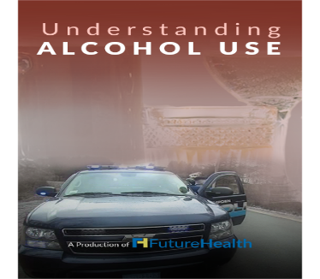 | UNDERSTANDING ALCOHOL USE 34:47 minutes  Alcohol is one of the most abused substances, and for many, this can be a tough subject to talk about. This documentary can help you understand the dire consequences of drinking. Alcohol abuse can lead to alcohol use disorder which is a disease that runs in families and ruins lives. This documentary will show you that with help, support & treatment, recovery is possible. Help your loved ones live a happier life.
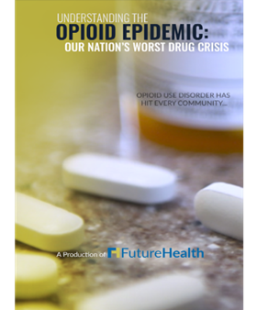 |  | UNDERSTANDING THE OPIOID EPIDEMIC:  OUR NATION'S WORST DRUG CRISIS 35:05 minutes  Opioid use disorder is a disease of the brain, not a personal weakness, and it does not discriminate. This documentary will help you better understand the seriousness of this disease, whether you suspect someone you love is battling addiction, or you want to learn more about this national epidemic.
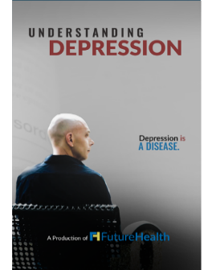 |  | UNDERSTANDING DEPRESSION 34:20 minutes  Depression is everywhere, do you know what it looks like? If you suffer from depression, it can be hard to describe to others about how you feel. This documentary will help you and your loved ones learn more about this condition, the dangers involved as well as many symptoms that can be managed through lifestyle changes.
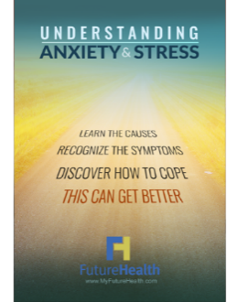 |  | UNDERSTANDING ANXIETY & STRESS 33:46 minutes  When your worries become constant, non-specific, and you have a hard time controlling them, you may need to think about finding help. Anxiety disorders are diagnosable, but there is good news: they can be managed.
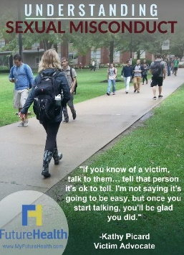 |  | UNDERSTANDING SEXUAL MISCONDUCT 37:36 minutes  The prevalence of sexual harassment in the U.S. is staggering. Title VII of the Civil Rights Act of 1964 made sexual harassment unlawful in the workplace and many colleges and universities have rules to protect students as well, unfortunately sexual harassment incidents are on the rise.
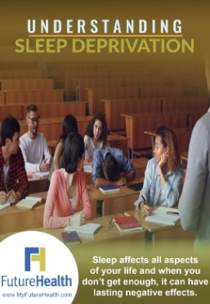 | UNDERSTANDING SLEEP DEPRIVATION 30:11 minutes  The importance of sleep should not be underestimated. The repeated lack of sleep, or sleep deprivation, can lead to weight gain, irritability, memory issues, trouble concentrating, weakened immune system, and more. Sleep deprivation is especially prevalent in college students. Academic demands, works, and social plans all play a part in how much or how little sleep students get.
  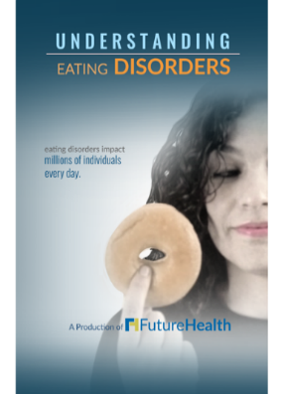 | UNDERSTANDING PERSONAL SAFETY 31:01 minutes  Do you pay attention to your surroundings? Personal safety--including everything from purse snatching to identity theft--is all about awareness and prevention. Arm yourself with knowledge. Hear real-life stories as told by the survivors of physical and sexual assault, bullying, and identity theft. This documentary will help you recognize danger signs and teach you simple actions to avoid being an easy target.  UNDERSTANDING EATING DISORDERS 31:30 minutes  Eating disorders affect every aspect of a person's life: biological, psychological, and social. At least one person dies every hour because of an eating disorder. This documentary will help you better realize the serious dangers behind this often-misunderstood illness, and the steps to overcome it.

health promotion

FutureHealth works with your institution to promote a healthy lifestyle. We provide our clients with materials to help promote available health resources.
Materials include:

Welcome Packet: A packet that introduces FutureHealth to administrators and goes through the program and frequently asked questions.

Brochures and Flyers: Designed to show members their benefits and our services.

Awareness Posters: Posters to promoted awareness on topics such as alcohol abuse, depression, anxiety, and basic health promotion.

Hotline Cards: These wallet sized cards have the phone numbers to various free hotlines for issues such as depression, mental health, domestic violence, drug issues, and more.

Sample Health promotion Materials (posters/Hotline cards)

Depression Poster Health Talks Poster:
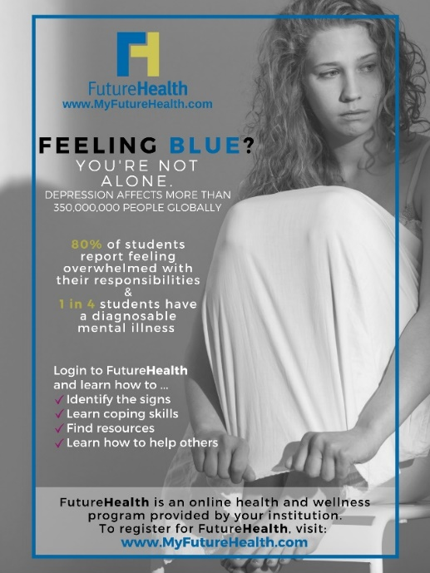  Hotline Card - 3.5” x 2” – Front and Back image   | 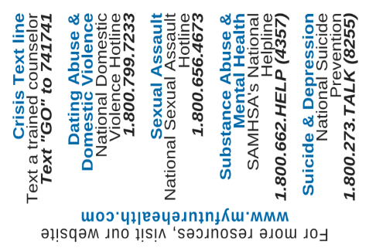  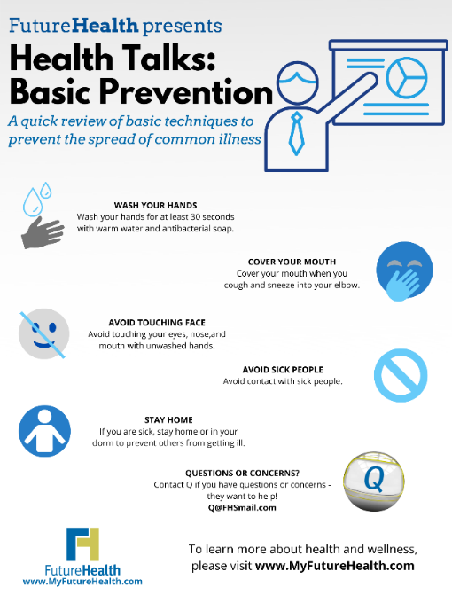
A STUDENT ASSISTANCE PROGRAM (ASAP)
In 2019 FutureHealth introduced our A Student Assistance Program (ASAP). By combining our FutureHealth Online program with a 24/7/365 counseling line, we are providing your students options as to how they want to address their mental health and wellness issues.

ASAP provides students with the ability to speak with a counselor about all issues big and small. Not all students take advantage of all the services provided to them on campus, ASAP provides students seeking anonymity or confidentiality an avenue to either study and learn online and/or to call and speak with someone over the phone, it’s their choice!

ASAP HIGHLIGHTS
- Hotline available 24/7/365
- Interpreters in over 200 languages
- Text and email also available
- Help on issues big or small
- Discounts for legal consultation including one
free 30-minute visit in person or over the phone
- Financial advisors available

How our counseling line is different from the others

- Whether your student is on campus or out of state, we coordinate with your students insurance carrier to find them an available In Network mental health provider, and we provide all the necessary information for the student to schedule an appointment.

- If one of our counselors refers a student for face to face visits with a mental health provider, FutureHealth will pay for the first three (3) visits, not the students insurance company.

- For international students, if they come from a country where mental health and wellness treatment is frowned upon, ASAP gives them the anonymity or confidentiality they seek when getting treatment.


FUTUREHEALTH HAS MORE TO OFFER

MORE BENEFITS THAN THE COMPETITORS
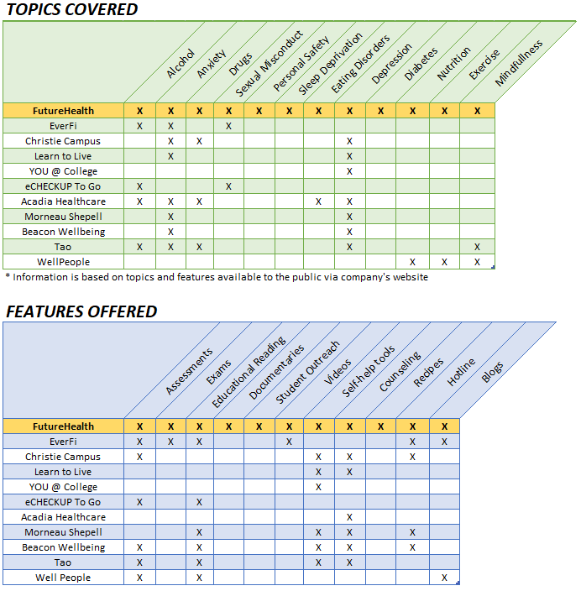

OUR GOAL AND GETTING STARTED

OUR GOAL
FutureHealth aims at arming our community’s youth with the knowledge and awareness to prevent risky behaviors that can lead to dangerous habits such as alcohol or substance abuse. We also care about mental health and provide material for our members to understand mental illness and hopefully to break the stigma surrounding it. We want everyone, not just our clients, to live a healthy and happy life.
FutureHealth’s mission is to help guide people to make positive lifestyle choices that will lead them on A Path to a Brighter Future. We will accomplish our goals by providing valuable information on critical health issues that we face in our everyday lives.

Getting Started
For additional information, please contact:
Michael T. Hmurcik
FutureHealth LLC
2071 Roosevelt Ave
Springfield, MA 01104

Direct: 413-858-2611
Cell: 813-997-5580
Office: 413-858-2610 x 125

mhmurcik@fhsmail.com
www.myfuturehealth.com

